St. Benedict’s & St. Mary’s N.S.
ANNUAL ADMISSION NOTICE
in respect of admissions to the
2024/2025 school year

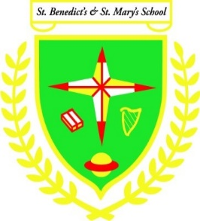
The Application Form for Admission is available on our website:stbenedictsandstmarys.com or can be obtained in person from school office. Please read the details below.

PART 1 - Admissions to the 2024/25 school year for mainstream pupils
Application and Decision Dates
The following are the dates applicable for admission to our Junior Infants Class
The school will commence accepting applications for admission on | 02/10/23
The school shall cease accepting applications for admission on | 21/12/2023
The date by which applicants will be notified of the decision on their application is | 19/01/24
The closing date to confirm acceptance of an offer of admission is | 31/01/24
Note: the school will consider and issue decisions on late applications in accordance with the school’s admission policy.
PART 2 - Special Class Application for admission 2024/25
Application and Decision Dates
The following are the dates applicable for admission our Special Class which caters for children diagnosed with ASD.
The school will commence accepting applications for admission to the special class on | 15/01/2024
The school shall cease accepting applications for admission to the special class on | 21/01/2024
The date by which applicants will be notified of the decision on their application for admission to the special class is | 02/02/2024
The period within which applicants must confirm acceptance of an offer of admission is | 9/02/2024

*Failure to accept an offer within the prescribed period above may result in the offer being withdrawn

PART 3
Number of places being made available in the 2024/25 school year
The number of available places in junior infants/first year | 19
The number of places being made available in the ASD class catering for children with: ASD SEN needs. | 0
The number of places being made available in other year groups | 0

PART 4
In respect of the 2023/24 school year, the total number of applications for admission received by the school was:
Breakdown of places allocated for the 2023/24 school year:
Number of places available to Junior Infants | 21
Number of applications received for Junior Infants | 21
Number of offers made and accepted under each criteria to Junior Infants. | Catchment area – 9  Siblings: 8  Staff: 0  Outside Catchment:12
Number of offers made and accepted to ASD Class | 0
Number of ASD applicants on waiting list | 5
Total number of offers made | 21

Available on website: stbenedictsandstmarys.com
Mainstream Application Form
ASD Application Form
Admissions Policy

