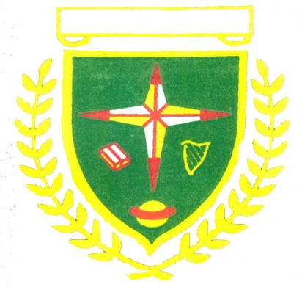**St. Benedict’s and St. Mary’s N.S. Board of Management**

**Annual Report 2022/2023**

**Building Works / Improvements**

New ASD Base Class and Outdoor Play Area

Upgrades to Railings

Newly Painted PE Hall

New Blinds in Classrooms and Hall

**School Ethos**

We are an inclusive Catholic school in the Diocese of Dublin. In co-operation with the parish priests and parents, Catholic children are prepared for the Sacraments of Reconciliation, First Communion and Confirmation.

Classes use the Grow in Love Programme for Religious Education.

RE Homework on Thursdays

**Policy/Plan Development**

Wellbeing

Child Safeguarding

Attendance

Parental Involvement

Admissions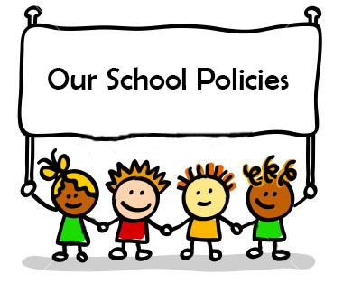

**Communication Information**

Parent/Teacher meetings held in November.

School reports will issue in June 2023.

Aladdin

Dojo

New School Website

**Curricular Development**

Literacy

Gaeilge

Numeracy

IT



**Staffing 2022-23**

8 Class Teachers

3.5 SEN Teachers

8 S.N.A.’s

1 HSCL

1 Clerical Officer

1 Caretaker

2 Cleaners

1 SCP Project Worker

**Parents’ Association**

Sacrament receptions

Policy Input

Parent Classes

Thank you for support and treats throughout the year.

The school will re-open on August 29th 2023. Míle Buíochas to all who helped make this year such a positive and productive one in St. Benedict’s & St. Mary’s N.S.