School Plan
“Love, Laugh, Learn”

General School details
Cėad Míle Fáilte and welcome to St. Benedict’s and St. Mary’s National School, Grange Park, Raheny, Dublin 5. Here at St. Benedict’s and St. Mary’s the pupil’s learning needs are at the centre of all planning in the school. Therefore the focus of our School Plan is the teaching and learning that takes place in the school.
Children are natural learners. They have an inbuilt curiosity and an eagerness to know more about everything – about themselves, about others and about the world around them. In St. Benedict’s and St. Mary’s we try to nurture this desire to know more, so that each child will be happy and fulfilled during their time with us.

History of our school
When the new estate of Grange Park opened in 1967/1968 the area was part of Raheny Parish. The Parish Priest of Raheny at that time was Monsignor Fitzpatrick and he applied for permission to establish two schools – a boys and a girls’ school to serve what was to be the new Parish of Grange Park.
On 5th May 1969, 80 children were on roll in Junior/Senior Infants and First Class in the newly built school, called St. Benedict’s. As the area developed the number on rolls increased rapidly so that by July 1973 there was a total of 972 children on roll from Junior Infants to Sixth Class. To cater for this number and in line with educational thinking at that time St. Mary’s Junior School was opened to cater for in Junior Infants to Second Class and St. Benedict’s catered for the older age group in Third Class to Sixth Class.
Numbers continued to increase at a very rapid rate in both schools, so that by 1978 there were approx. 1000 pupils in each school making St. Mary’s the largest junior school in Ireland with an enrolment of 1100 pupils.
At this peak both St. Benedict’s and St. Mary’s had 9 classes at some levels. In addition to a total of forty classrooms between both schools it was necessary to erect seven prefabricated classrooms to cater for all the children attending both schools.
In the late eighties the enrolment began to decrease due to demographic changes. The prefabricated classrooms were removed and the existing playing field was developed.

St. Mary’s moved premises to refurbished classrooms to St. Benedict’s in 1995. In March 1996 St. Mary’s building was given to the community as a Resource centre. Both schools functioned side by side until August 30th 2007 when St. Benedict’s SNS and St. Mary’s JNS amalgamated to form St. Benedict’s and St. Mary’s N.S. catering for boys and girls from Junior Infants to Sixth Class.
Since the beginning in 1969, thousands of boys and girls have passed through both schools. They are all remembered by their teachers – past and present – with pride and admiration and deep gratitude to their parents for their constant interest and unfailing co-operation in their education and school activities.
We have many pupils now whose parents were pupils themselves. We also have a lot of new families moving into the area and we have welcomed a number of non-national families too.
Personnel
St. Benedict’s and St. Mary’s is a 13 teacher school with an administrative Principal, seven mainstream class teachers, 4 Special Education teachers, one shared Home School Liaison teacher with Ardscoil La Salle and 7.83 full time Special Needs Assisstant positions. 1 Special Class teacher caters for 6 children with ASD diagnosis. The school has one secretary, one caretaker and two cleaners.
Under the School Completion Programme, the school has the services of an SCP Co-ordinator and a part time Project worker.
Visiting personnel include a Games Promotion Officer from Náomh Barróg GAA. The school also has a School Warden from Dublin City Council.

Teaching Staff
- Ms J. Plunkett
- Ms. C. Walsh
- Ms. Ní Chomhraí (Secondment)
- Mr. C. Lyons
- Ms. L. Roche
- Ms. A. Flynn
- Ms. O. Finlay
- Ms. M. Mullen
- Ms. N. Casey
- Ms. E. McGuinness
- Ms. N. Nolan
- Ms. L. Gaffney
- Ms. F. Terry
- Mr. S. Kenny
- Ms. P. Sadlier
- Ms. N. Kearns
Special Needs Assistants
- Ms. T. McDonnell
- Ms. T. Davis
- Ms. M. Griffiths
- Ms. J. Cole
- Ms. L. Browne
- Ms. C. Dillon
- Ms. S. Murray
- Ms. T. O’Shea
- Ms. N. Bridgeman

Board of Management
Chairperson/Patron’s Nominee: Ms. Breda Murray
Patrons’ Nominee: Ms. Lisa Dowling
Teacher’s Representative: Ms. Lucy Roche
Secretary/Community Representative: Vacant
Treasurer/Community Representative: Mr. Ritchie Egan
Principal: Ms. Jennifer Plunkett
Parents’ Representative: Mr. Edward Burke
Parent’s Representative: Ms. Leona Brolan

Child Protection

Designated Liaison Person DLP Ms. J. Plunkett Principal

Deputy Designated Liaison Person DDLP Ms. A. Flynn Deputy Principal

Parents Association
A Parents’ Association was founded in 1997, but was disbanded. An attempt was made to restart an association in June 2004 but was unsuccessful. A second attempt was made in 2007 but again was unsuccessful. In 2017, under the guidance of the National Parents Council, we established a Parents Association. The committee is currently operating very successfully.

Chairperson Ms. A. Trimble
Co – Secretary Ms. N. Conroy
Co – Treasurer Ms. C. Evans
Ms. E. Cummins
Committee member Mr. S. Kelly
Ms. U. Dennis
Ms. D. Maguire

Subjects
St. Benedict’s and St. Mary’s follows the NCCA Revised Curriculum as set out by D.E.S. in all curricular areas.
In line with new Primary Language Curriculum, we are implementing this curriculum in all classes in both English and Irish.
As St. Benedict’s and St. Mary’s N.S. is a Catholic school, we deliver the Catholic Preschool and Primary Religious Education Curriculum and teach the Grow in Love to children whose parents have chosen to have their children avail of this.
Religious Education is supported by the Archdiocese of Dublin and regular inputs from the Diocesan advisors.

Books
Book Rental Scheme (BRS) is offered to all pupils. It was established to reduce the cost of books and school supplies to parents. Parents sign a contract to participate in the scheme which includes all text books, workbooks, readers, copies, pencils, rulers, pens, license fees, art materials and photocopying.
The cost of the scheme is €90 per child annually. We have introduced a sibling discount this year. The fee for the second child is €70 and each subsequent child’s fee is €40.
Library books are freely available for children’s use.
400 PM books available from levels 1 - 30 to ensure each child is reading at their own level.

Usual opening and closing times
School opens to receive pupils at 8.40 am.
School closes at 1.25 pm for infant classes.
School closes at 2.25 pm for all other classes.

Covid opening and closing times
School opens to receive pupils at two entrances at 8.40am
School closes at 1.25pm for Junior Infants and 2.25pm for 1st-6th Class

School lunches
The school is provided with lunches under the School Meals Scheme. The school follows a healthy eating policy and so certain food and drinks not permitted.
In line with our Green School initiative and Covid 19 Response plan, children are required to take home all lunch contents to be disposed of at home.

Uniform
Girls: White shirt/blouse
Grey Skirt
Non crested Green Jumper/Cardigan Available in Department stores

Boys: Grey Shirt
Non crested Grey Jumper
Grey Trousers Available in Dept. Store (generic)
School Tie Available in Pat O’Farrell Schoolwear

School Tracksuits with crest and yellow non crested Polo Shirts are available from Pat O’Farrell Schoolwear, 4 Town Centre, Portmarnock. Tel: 01 8463512 Fax. 8463127.
Ms. O’Farrell will be in the school the first Tuesday of June each year to sell tracksuits but they are available from the store throughout the year also.

Vision Statement
LOVE, LAUGH, LEARN
Love beyond words…Laugh everyday…Learn all you can
St. Benedict's and St. Mary's National School aims to foster the spiritual, moral, cultural, mental and physical development of all pupils. We model and promote a philosophy of life inspired by belief in God and in the life of Jesus Christ. We believe that a happy child is a successful one. Our vision statement “Love, Laugh, Learn” reflects our shared beliefs and aspirations.
We value:
- the happiness and well-being of children, families and staff.
- caring staff who respect and know the children very well.
- the development of self-confidence, self-motivation and independence.
- working in partnership with others to meet the needs of all the children and their families through co-operation, collaboration and teamwork.
- exciting but safe and secure indoor and outdoor spaces, where children can explore, discover and experiment.
- the natural environment, the local community and the wider world.
- a stimulating and challenging curriculum, suited to children’s needs, enabling them to reach their full potential across all areas of learning.
- praise and celebration of the achievements of every child.
- raising aspirations and a commitment to lifelong learning.
- all aspects of life and culture in Ireland; celebrating differences, diversity, core values and preparing children for life in the modern world.

We aim to:
- ensure that all children enjoy learning, achieve their potential and become independent life-long learners.
- build effective, collaborative partnerships with families and the wider community.
- achieve a consistently high level of pupil achievement, preparing pupils for the challenges, opportunities, responsibilities and experiences of adult life.
- provide a positive, safe and stimulating environment for children to learn, where all are valued.
- plan and deliver high-quality learning experiences based on a broad and balanced curriculum.
- create a fully inclusive environment with equal opportunities for all.
- foster empathy in order to encourage responsible citizenship.
- ensure that the children learn to value and respect religious and cultural differences.

The staff, Board of Management and parents endeavour to develop our school in the light of this vision statement.

This plan will be reviewed by the Board of Management every year.
This plan was adopted by the Board of Management on
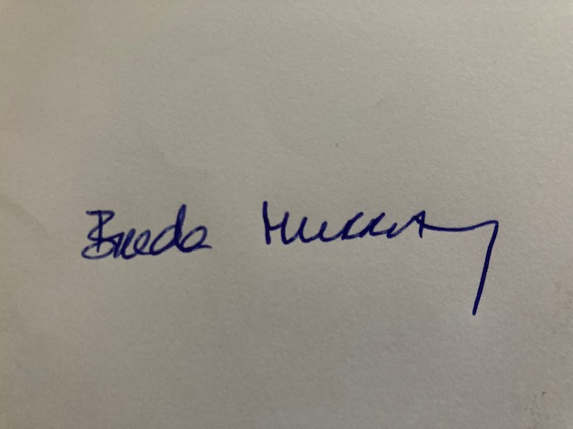
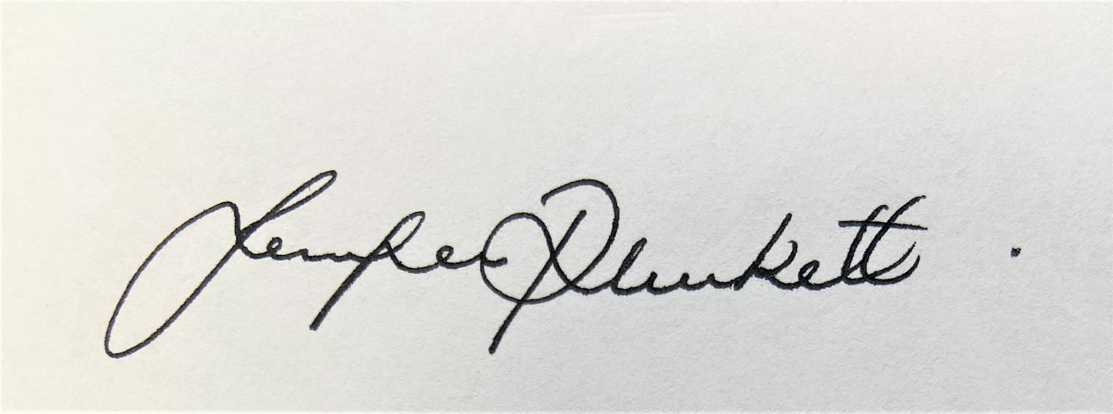
Signed: _________________________ Signed: __________________________
Chairperson of Board of Management Principal
Date:___________ Date: ____________
Date of next review: ______October 2023

